AIML SESSION 11 ASSIGNMENT SUBMISSION

Name of Student : Vaibhav Vijay Kate
Domain/Subject : AIML (Artificial Intelligence & Machine Learning)
College : Government Polytechnic College Washim
Branch : Information Technology
Session : 11

Q1
Q1. Basic try-except)
Write a program that takes two numbers as input from the user and prints their
division.
Use try-except to handle the case when the user enters non-numeric input
ValueError).
Print a friendly message if an error occurs.

Program Code:
try:
a = int(input("Enter 1st Number: "))
b = int(input("Enter 2nd Number: "))
c = a / b
print("Division:", c)
except ValueError:
print("Please enter only numbers.")

Output Screenshot: 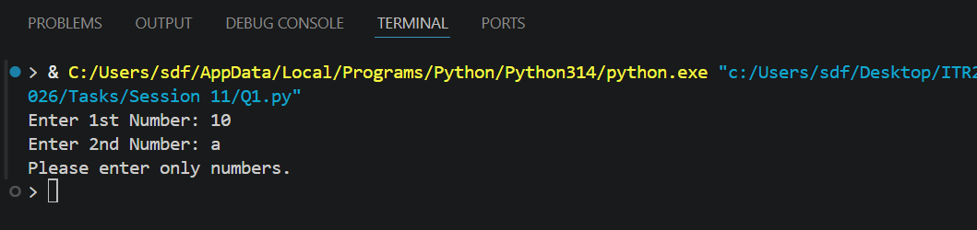

Q2
Q2. Handling ZeroDivisionError)
Write a program that divides two numbers entered by the user.
Use try-except to specifically catch ZeroDivisionError and print:
"Error: Division by zero is not allowed."
Also handle ValueError for invalid input.

Program Code:
try:
a = int(input("Enter a 1st Number: "))
b = int(input("Enter a 2st Number: "))
c = a / b
print("Division :", c)
except ZeroDivisionError:
print("Error: Division by zero is not allowed.")
except ValueError:
print("Error: Invalid input. Please enter numeric values.")

Output Screenshot: 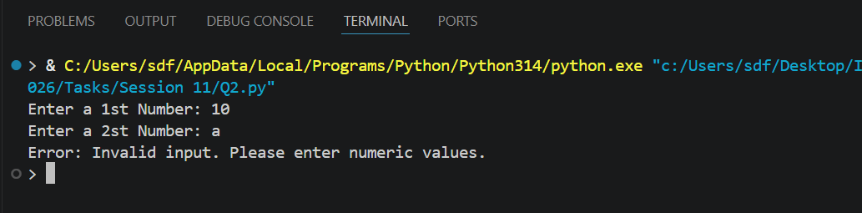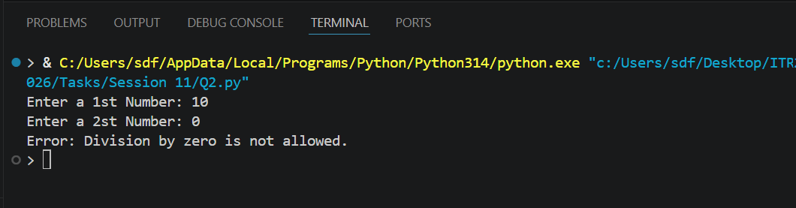

Q3
Q3. Multiple except Blocks)
Create a program that performs division and also tries to convert a string to
integer.
Handle both ValueError and ZeroDivisionError with separate except blocks and
appropriate messages.

Program Code:
try:
# Division
a = int(input("Enter the 1st Number: "))
b = int(input("Enter the 2nd Number: "))
print("Division:", a / b)
# String to Integer Conversion
s = input("Enter a number in string form: ")
num = int(s)
print("Converted Integer:", num)
except ZeroDivisionError:
print("Error: Division by zero is not allowed.")
except ValueError:
print("Error: Invalid input. Please enter a valid number.")

Output Screenshot: 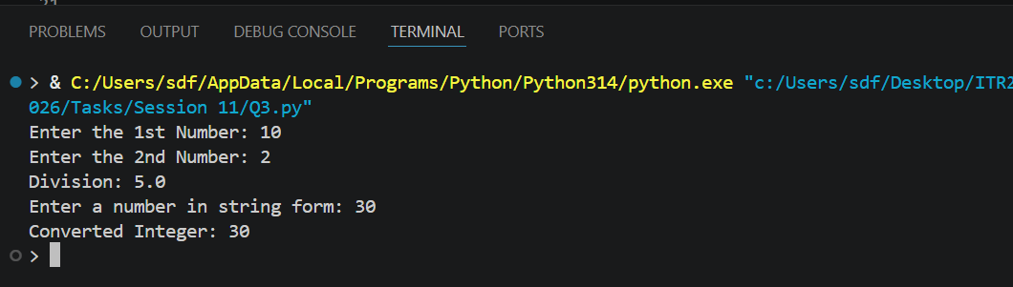

Q4
Q4. Using else)
Write a program that takes two numbers and divides them.
Use try, except, and else.
The else block should print "Division performed successfully!" only when no
exception occurs.

Program Code:
try:
a = int(input("Enter a 1st Number: "))
b = int(input("Enter a 2st Number: "))
c = a / b
print("Division :", c)
except ZeroDivisionError:
print("Error: Division by zero is not allowed.")
except ValueError:
print("Error: Invalid input. Please enter numeric values.")
else:
print("Division performed successfully!")

Output Screenshot: 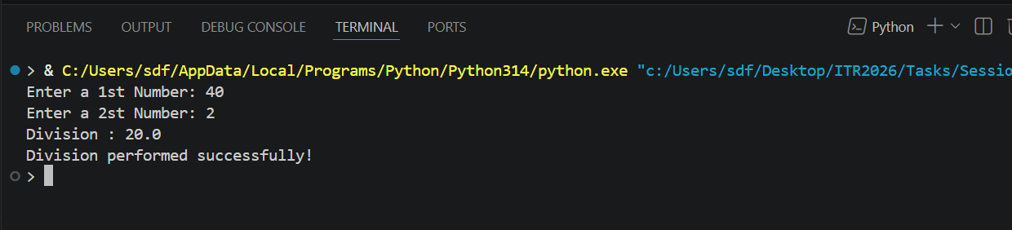

Q5
Q5. Using finally)
Modify the division program to include a finally block that always prints:
"Program execution completed."
Demonstrate that finally runs whether an exception occurs or not.
Add comments explaining the purpose of finally.
Session 11 (AIML) - Assignment Questions 1

Program Code:
try:
a = int(input("Enter a 1st Number: "))
b = int(input("Enter a 2st Number: "))
c = a / b
print("Division :", c)
except ZeroDivisionError:
print("Error: Division by zero is not allowed.")
except ValueError:
print("Error: Invalid input. Please enter numeric values.")
else:
print("Division performed successfully!")
finally:
print("Program execution completed.")

Output Screenshot: 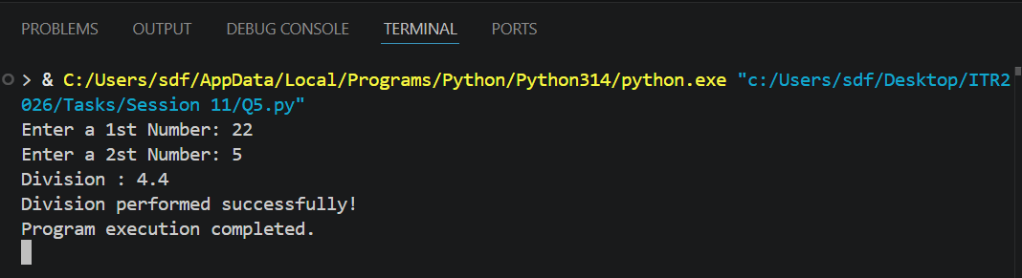

Q6
Q6. Combined try-except-else-finally)
Write a complete division program using all four blocks (try, except, else, finally):
Handle ValueError and ZeroDivisionError.
Print success message in else.
Always thank the user in finally.

Program Code:
try:
a = int(input("Enter a 1st Number: "))
b = int(input("Enter a 2st Number: "))
c = a / b
print("Division :", c)
# Handle ValueError and ZeroDivisionError.
except ZeroDivisionError:
print("Error: Division by zero is not allowed.")
except ValueError:
print("Error: Invalid input. Please enter numeric values.")
else:
print("Division performed successfully!")
finally:
print("Program execution completed.")

Output Screenshot: 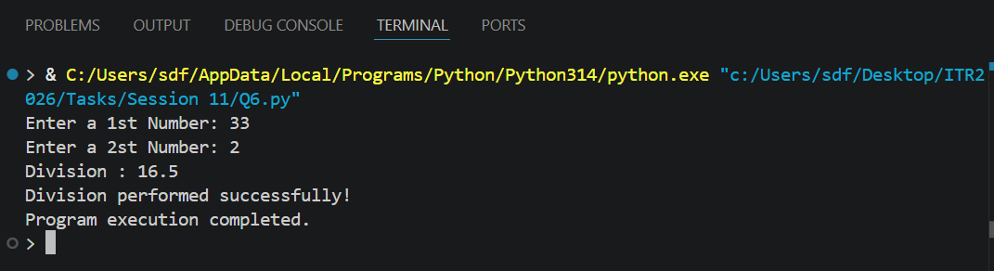

Q7
Q7. Practical - Age Input)
Write a program that asks the user for their age.
Convert the input to integer.
If the age is negative, raise a ValueError with message "Age cannot be
negative."
Handle the exception gracefully and print a suitable message.

Program Code:
try:
age = int(input("Enter your age: "))
if age < 0:
raise ValueError("Age cannot be negative.")
print("Your age is:", age)
except ValueError as e:
print("Error:", e)

Output Screenshot: 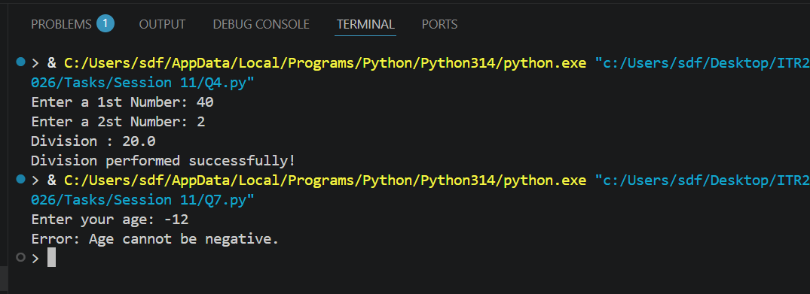

Q8
Q8. Multiple Exceptions in One Block)
Create a program that:
Takes a number as input.
Divides 100 by that number.
Handle both ValueError and ZeroDivisionError in a single except block using a
tuple.
Print a combined error message.

Program Code:
try:
num = int(input("Enter a number: "))
result = 100 / num
print("Result:", result)
except (ValueError, ZeroDivisionError):
print("Error: Please enter a valid non-zero number.")

Output Screenshot: 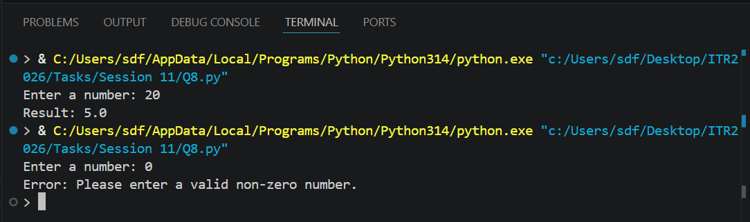

Q9
Q9. Debugging Exception Code)
The following code has issues. Correct it and add comments explaining the fixes:
Python
try
num = int(input("Enter a number: "))
result = 100 / num
print("Result:", result)
except ValueError
print("Please enter a valid number")
Session 11 (AIML) - Assignment Questions 2
except:
print("Some error occurred")

Program Code:
try:
# Take input from the user and convert it to an integer
num = int(input("Enter a number: "))
# Divide 100 by the entered number
result = 100 / num
# Display the result
print("Result:", result)
# Fix 1: Added a colon(:) after except ValueError
except ValueError:
# This block runs if the user enters a non-numeric value
print("Please enter a valid number.")
# Fix 2: Used a general except block with a colon (:)
except:
# This block handles any other unexpected errors
print("Some error occurred.")

Output Screenshot: 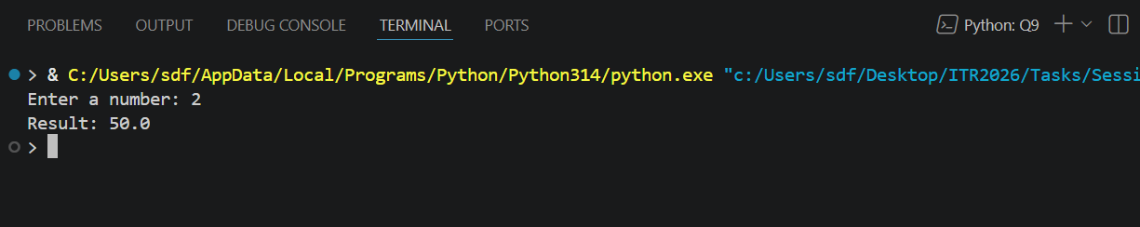

Q10
Q10. Mini Project - Exception Handling)
Create a Simple Calculator with exception handling:
The program should run in a loop and show this menu:
text
1. Addition
2. Subtraction
3. Multiplication
4. Division
5. Exit
Take user choice and two numbers.
Perform the operation inside try block.
Handle ValueError (invalid input) and ZeroDivisionError (for division).
Use finally to print "Operation attempted." after every calculation.
Continue until user chooses to exit.
Session 11 (AIML) - Assignment Questions 3

Program Code:
while True:
print("\n===== Simple Calculator ======")
print("1. Addition")
print("2. Subtraction")
print("3. Multiplication")
print("4. Division")
print("5. Exit")
choice = input("Enter your choice (1-5): ")
if choice == "5":
print("Thank you! Calculator Closed.")
break
try:
num1 = int(input("Enter First Number: "))
num2 = int(input("Enter Second Number: "))
if choice == "1":
print("Result:", num1 + num2)
elif choice == "2":
print("Result:", num1 - num2)
elif choice == "3":
print("Result:", num1 * num2)
elif choice == "4":
print("Result:", num1 / num2)
else:
print("Invalid Choice! Please enter 1 to 5.")
except ValueError:
print("Error: Please enter valid numbers.")
except ZeroDivisionError:
print("Error: Division by zero is not allowed.")
finally:
print("Operation attempted.")

Output Screenshot: 